1. ______ Physical Geography
2. ______ Diffusion
3. ______ Spatial Analyses
4. ______ Process
5. ______ Intermediate Direction
6. ______ Pattern
7. ______ Immigration
8. ______ Relative Location
9. ______ International Date Line
10. _____ Absolute Location

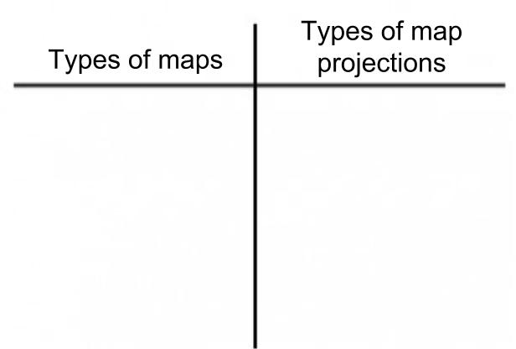

Define, list notes example, and give your own example of each:

Formal Region-

Functional Region-

Perceptual Region-

Push Factor-

Pull Factor-

- Exa. 91°W, 40°N
- The mixing of people, cultures, food, etc.
- Exa. Between Houston and Galveston
- Between Cardinal Directions, exa. NW
- Study of relative location of people, places, and events
- A repeated regular phenomenon
- Marker identifies the change of day; 180°
- Continues action, repeats to form pattern
- Movement of people to new regions
- Study of process and patterns that affect the environment

Draw & label Examples of Map Projections:

