Explain what the image is showing and how they were formed and/or changed.
A. B.
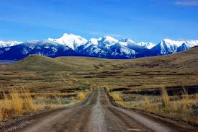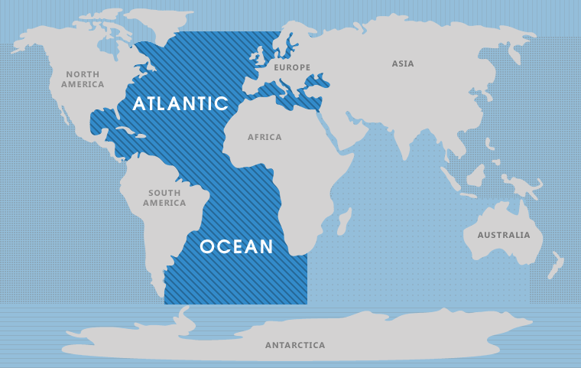

C. D.
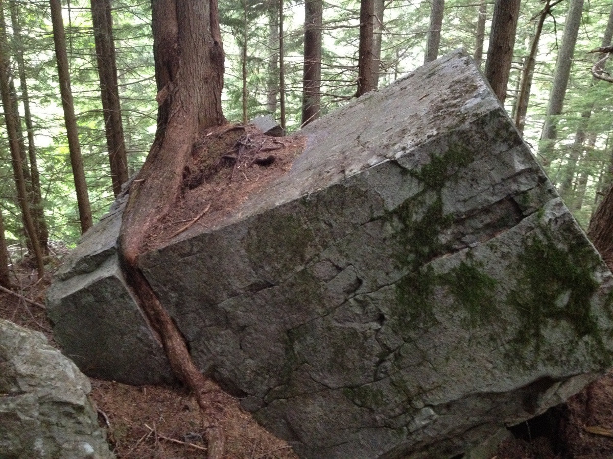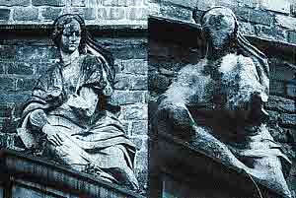

Draw the Hydrological Cycle.

The difference between weather and climate is…

The Ring of Fire is Significant because…

Climate is affected by…

Define these terms:
Isthmus-

Hearth-

Glaciation-

Scarcity-

Water Hemisphere-

North American Drift-

