Brexit
UK reactions to Brexit
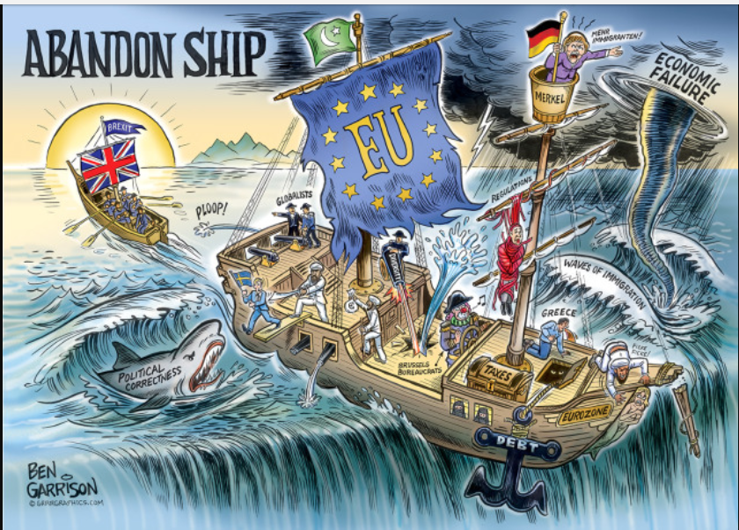
Examine the image above. What are some of the reasons for England’s exit from the European Union?
In your opinion, what is the strongest reason for an exit of the EU? Why?

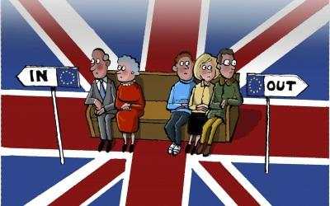
Using the image above, who is in favor of leaving the EU and who is in favor of staying in the EU?
Why do you believe there is a divide between the two groups?

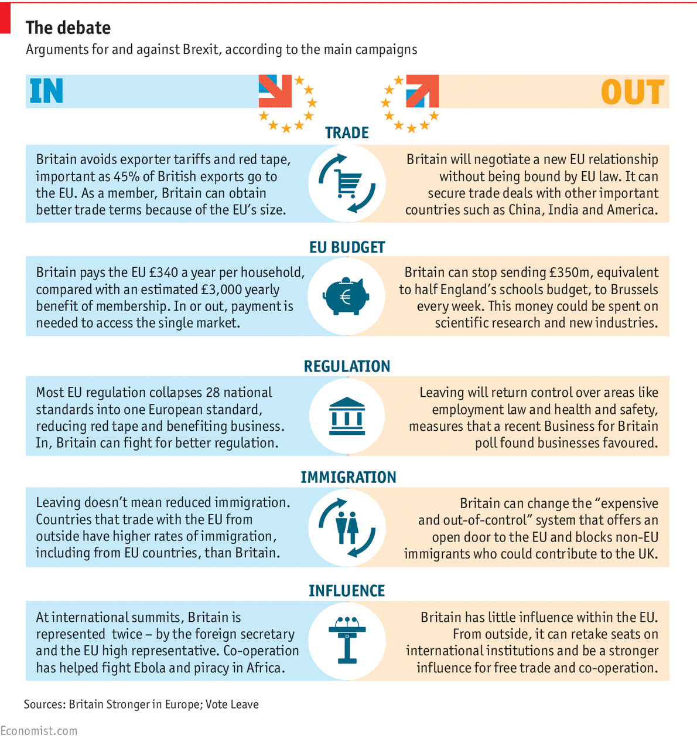
Examine the chart above. How would leaving the EU affect controlling England’s immigration?
How will England’s influence change leaving the EU? (Describe it before, when England was in the EU, then describe how it will change leaving.)

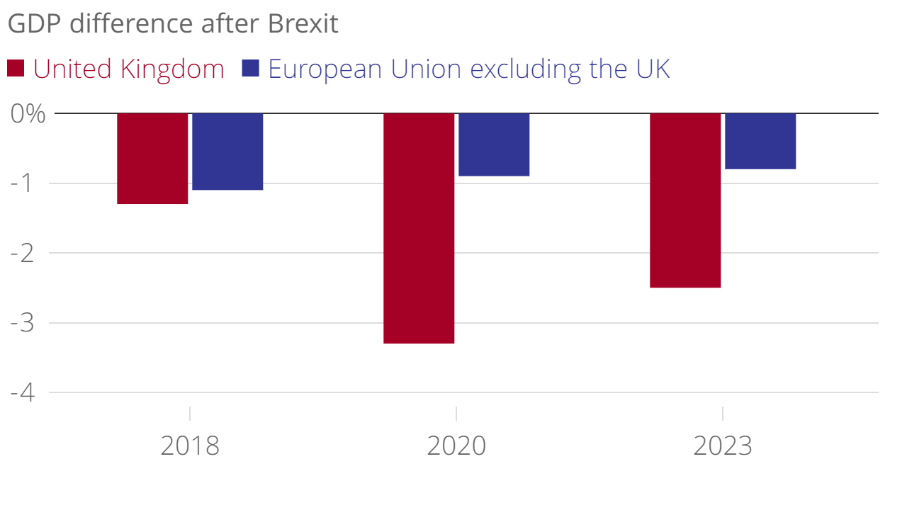
Examine the graph above. How does England’s forecasted GDP compare to the EU’s?

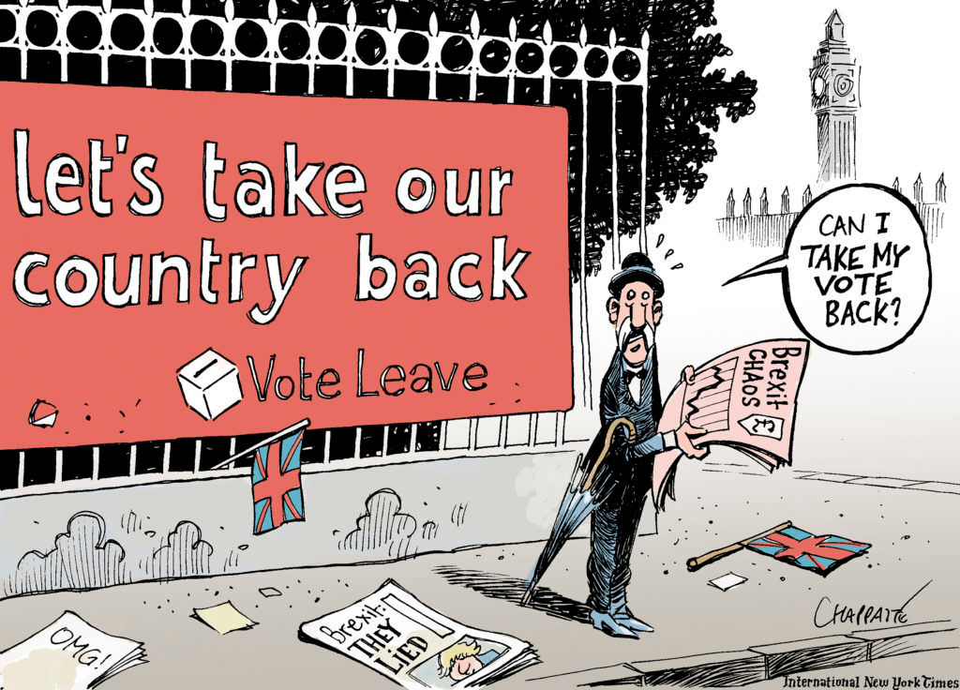

Using the picture above and the others we have examined. How did Britain leave the EU? Is there anything Britain could do to change their decision?

Summary.
Write a 5-6 sentence (minimum) paragraph supporting or criticizing England’s EU exit. Cite at least two specific examples from this handout and videos and/or notes taken in class. Does the Brexit remind you of anything in our election this year? If yes, or no, explain how or how not and what we can learn from England’s exit of the EU.
I think that England (should or should not) leave the European Union. I believe England (should or should not) leave the EU because ________________________________________ ____________________________________________________________________________ and ___________ _____________________________________________ _______________________________. I believe England (should or should not) leave the EU because evidence was found in ___________________________________ ______________________________________________ and it says _____________________________________
_____________________________________________. More evidence was found in _______________________ ______________________________________________ supporting my decision to (leave or stay in) the EU, it said ______________________________________________ ______________________________________________.

England’s decision to leave the EU (does or does not) remind me of the United States political campaign because _______________________________________ ______________________________________________ __________________________________________________________________________. One thing we can learn from Brexit is ____________________________________________ ___________________________________________________________________________.

