- _______________ Revolution = 1st _________________ Revolution
  - Fertile soil and fresh water lead to ______________ settlements.
- ________________ in agriculture = 2nd ________________ revolution.
  - Agribusiness: Positive – 1.______________________________________________
2.______________________________________________
Negative – 1.______________________________________________
2.______________________________________________
- Agriculture Revolution leads to _________________ Revolution.
Positive – 1._______________________________________________
2._______________________________________________
Negative - ??? _____________________________________________

- Diffusion = Spread of _____________ and _____________.
  - Latino’s __________ culture when they immigrate.
- European Union and NAFTA ______________ economic development.
  - EU - common currency = __________
- economic ____________ from the common _____________
- _____________ cooperation
  - NAFTA _______________ __________________ of goods in member nations.
    - Boosts _____________ economy.

- ______________ Industry = Homemade

______________ Industry = Mass production

_______________ of ____________________.
- _______________ Agriculture = Family survival
Located – South __________, A________, and Southeast _______
_______________ Agriculture = Mass Production for $$$
Located – North ________________, E____________, and A________________
- _______________ Countries have highly developed infrastructure and jobs in the _______________ and _________________ sector.
Deindustrialized = ____________ primary and secondary jobs.
- Metropolitan has Central ______________ District and Mass _________ System. Population of _____ million.
Megalopolis = chain of ______________ areas.
- _______________ Region functions politically, socially, and economically as ___ unit. Houston Metropolitan is a Functional Region.
Ex. ___________ ____________
- New York is successful due to
  - T________
  - R________ and P_______
  - I____________

- Port cities grow and are important for ________ and __________________.
Ex. S__________________
H__________ K_________
N______ Y________________
H___________ and G____________
- New _____________ policies and less oil _________ _______________ = less _____________ on ___________ oil.
- _____-_____________ resources have ___________ impact on the ________________.
- Water ______________ = Lack of H₂O
Ex. A_______, and the M_____________ E______________________
  - Surface mining for _________________ is better for the environment because ___________ land must be put back ____________ after ___________ is ____________________.
- Reasons against offshore oil drilling:
  - Damage to _________ ______________.
  - Need for _________ to repair _______________.
  - Continued _____________ on ____-_____________ energy sources.
- Support for oil drilling in ANWR (A___________ N________________ W_______________ R______________): Only __________% of ______________ would be affected.
- Urban area = City ___________________ + _____________________________
- Well-developed __________________ allows urban areas to have
  - I__________________ C__________________
  - T____________________
  - E______________________ S________________________________

- Complete the graphic below:
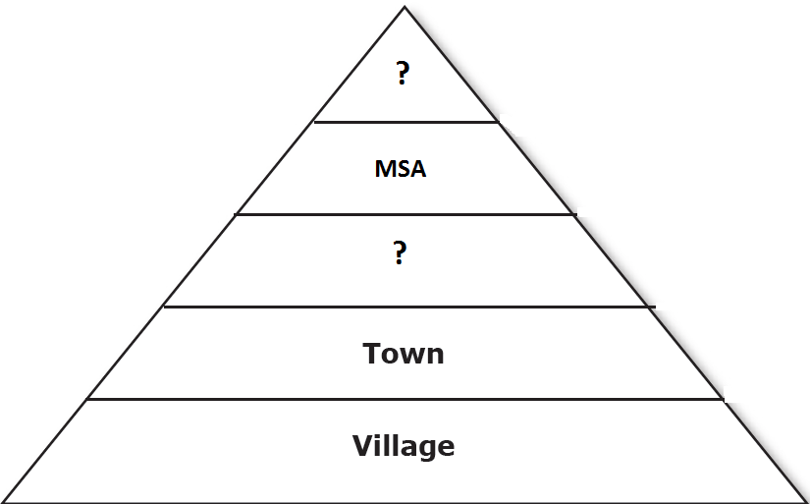
- __________________ factors _________________________ people to move to _______________.
  - EX. Jobs in _____________________________
- __________________________ of cities . . . M_________________ P ______________________ is possible in cities with a______________________ w__________________ f____________________.
- Special Service Cities include:
  - Large __________________ area
  - Important ______________________ center
  - Headquarters for __________________ companies
  - _______________________, ________________________, and _______________________
- W________________ C___________________ said, “Some _____________________ exist to _________________ other _____________________.”
- The hexagon map shows __________________ _______________________ available to _______________________ of these __________________ areas.
- Portland, ________________________ is an important ______________________ ____________ because it provides __________________________ and has __________________ ________________ that is welcoming to ______________________ companies.
- There are _________ US Courts of __________________ and they are ________________ based on __________________________ ________________________.
- A ________________ city has the greatest __________________ in a ____________________ and _________________________.
- Boston and ________________ share characteristics . . . ___________ shifted from colonial _____________________ to modern _________________________.
- New York __________________ is one of the _______________ best ___________________.
- In Texas, the vast majority of people and ____________________ are located in the ____________ _______________________ ______________.
  - Dallas/______ _________________________
  - _______ _________________________
  - ________________________________
- Houston - __________________________________
- __________________ _______________, ____________________
  - Most ____________ city in ____________ America
  - ________ million in CSA
  - ___________ and _______________ are the largest industries
- Paris - ______________ ______________________ of Europe.
- _______________ is home to ___________________________, South Asia’s ___________ industry.
- Three-fourths of the people living in __________ ___________ are in __________________ countries.
- One negative to megacities = ________________ living conditions in which most _________ ___________ live.
- Two motivations for people to move to the city = greater opportunities for ______________ and access to ___________________ ________________.

- Draw a shoreline shaped by deposition.

- One quality of democratic societies is that they share a commitment to ______________________ ___________________.
- N A F T A Three Countries in NAFTA:
__ __ __ __ __ *C__________________
__ __ __ __ __ *U________________ S_____________ of
__ __ __ __ __ _______________________
__ __ __ __ *M__________________
__ __
__ __
__ __
__

- Climographs show annual __________________________ and ___________________________.
Low Latitude = _____________________ and __________________ all year
Mid Latitude = ___________-_______ summer and __________________ winter
High Latitude = _____________________ winter, and ___________ ___________ summer.
- Soil is directly controlled by _______________________ ________________________ and ___________________________ for its development.
- Karl ________________ and Friedrich _________________ encouraged ___________________ to improve the __________________ conditions by ____________________ the ____________________ system.
- In Southeast Asia a major effect on geography is ______________________ that help determine types of _______________________ grown.
- New ________________ _______________________ have __________________ production and caused ____________________________ decline in __________________ exports since 2004.
- In the late 1800s, the cultivation of _______________ ____________________ by a large number of ____________________ results in a shift from ______________ - __________________ (_______________) to ________________________ farming.
- ________________ Economy like the _______________ ________________ says:
“A group of __________________ makes _____________ economic __________________. The group ________________________ value to goods and services. The group _____________ how to produce them and who gets them.”

